DeSForM 2013 - 8th International Conference on Design and Semantics of Form and Movement
HOTEL RESERVATION
Hotel | Changguanxi Hotel  No.1 Yuanxi Avenue, Taihu New Town, Hubin District, Wuxi 214071, China  +86 (0510)85912777  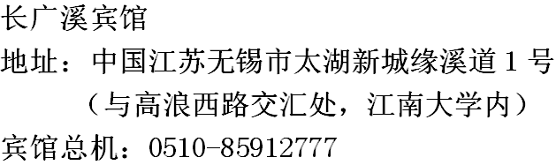
Room | Standard twin room
Price | Approximately 30EUR, depending on currency exchange rate  If you are a student (including PhD students), we provide a sponsorship of half-price. Please indicate below. And please attach to this reservation with a document that proves your student status.  [ ] I am a student.
Check-in date | DD/MM/2013
Check-out date | DD/MM/2013

Name |  | Gender
Nationality |  | Passport number
Telephone |  | Email
If you are going to share the room, please provide information of your room mate:
Name |  | Gender
Nationality |  | Passport number
Telephone |  | Email

